**What is Gen-ai:**

AI systems that can produce the high-qualitycontent specially **text** & **images** and **audio**

**Ai systems:** AI systems are built using algorithms and models that enable them to analyse data, make decisions, learn from experiences, and adapt to new information.

1. **Narrow AI (Weak AI):**
   * Designed and trained for a specific task or a narrow set of tasks.
   * Examples include virtual personal assistants (Siri, Alexa), image recognition systems, and recommendation engines.
2. **General AI (Strong AI):**
   * Hypothetical AI systems that possess the ability to understand, learn, and apply knowledge across a wide range of tasks at human levels.
   * Currently, true general AI does not exist, and AI system

**Ex: open ai ChatGPT**

Bard

Microsoft Bing

Daily life’s we are using Ai:

Web search recommendation system

++==================================

Many ai tools are complex and expensive to build so Gen-ai making them very easily to build

Gen-ai which is used to generate the beautiful images by the prompt

Gen-ai generates audio also

We can put an image or video along with audio

Even we can create video cloning also

How Gen-ai works????

Ai is a set of tools

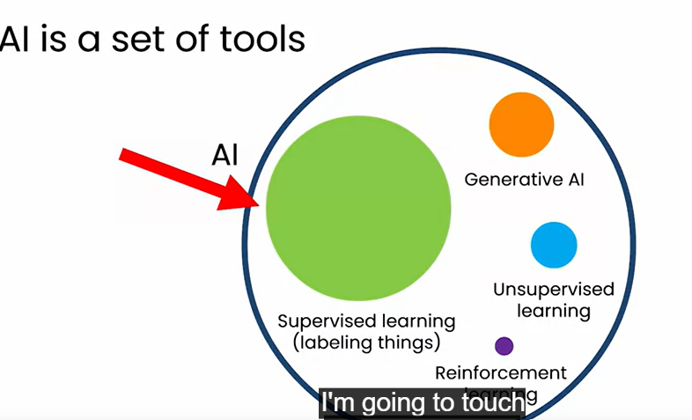

Supervised learning:

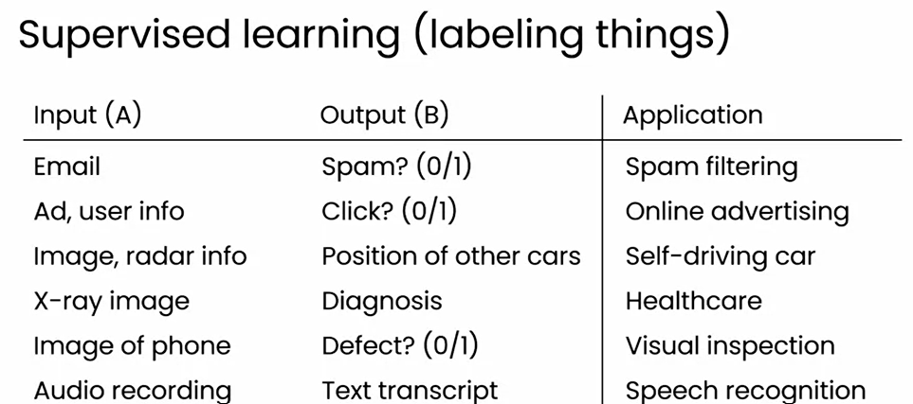

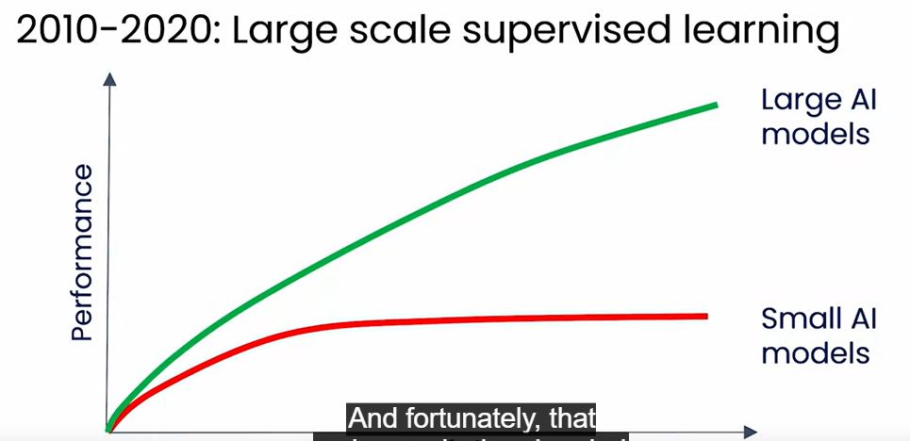

Even we train with 100s and 1000s of the data the ai model is unable to recognize or not that much accuracy

So large models the feeded with large amount of data will have high accuracy

Large scale supervised learning remains important today but this idea for very large models for labelling things brings the **Gen-ai** into picture

Generating text using LLms

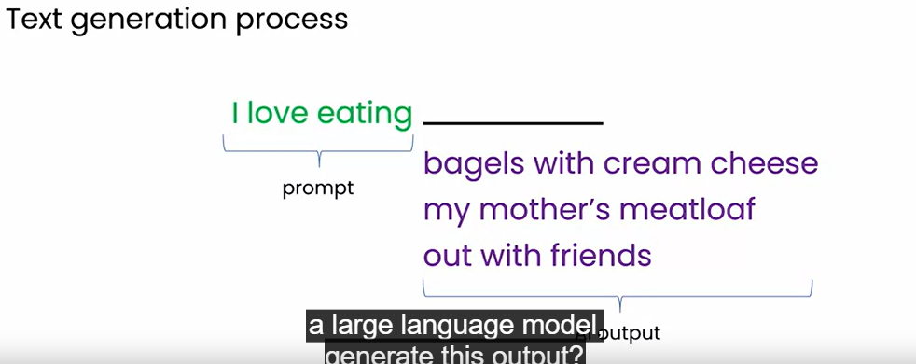

LLMs are using supervised learning (a->b) to repeatedly predict the next word.

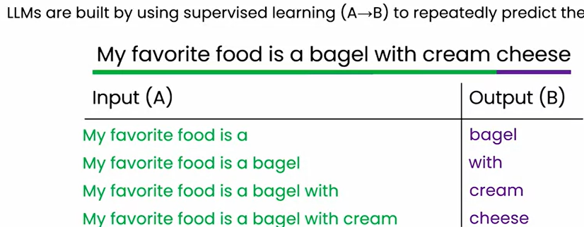

When we a train a very large ai system a lot of data (trillion and billons of words) then you will got the LLMs like ChatGPT so it will able to generate some more words additionally about the prompt…

LLms are giving a new way to find the informations.

Give the prompt clearly

Example

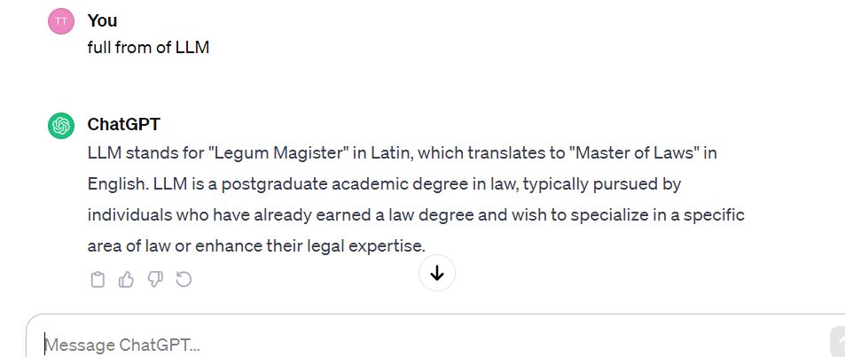  
 so without giving correct prompt we will not get required output:

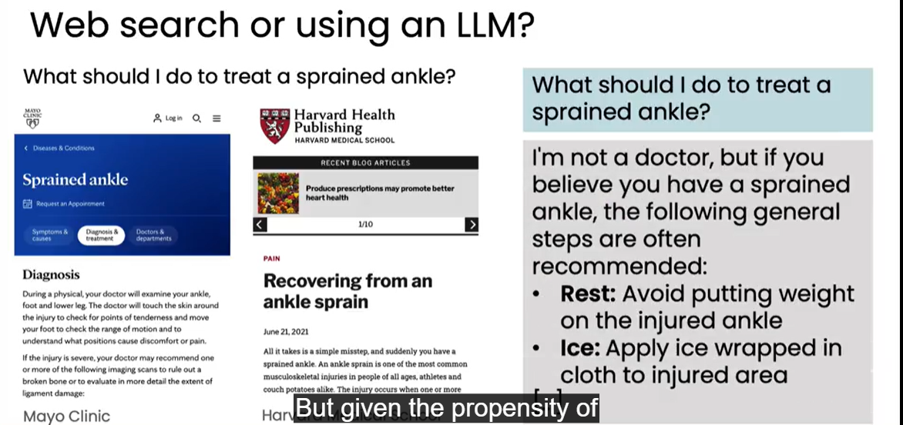

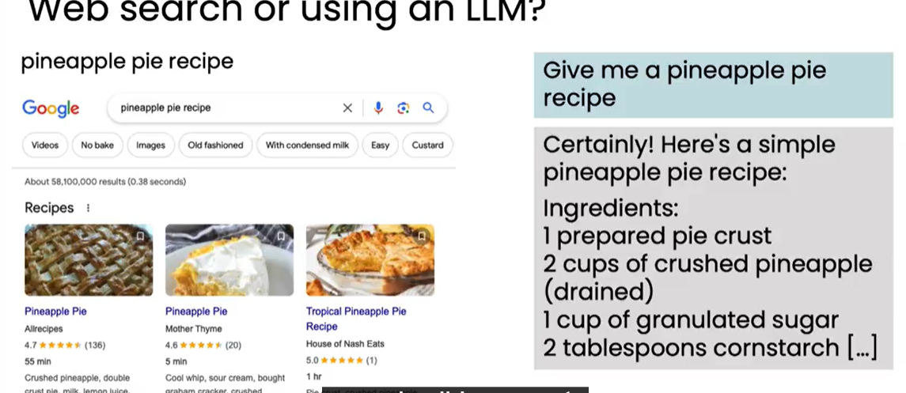

Pineapple pie where I can go to web search and I could multiple recepie I can choose the best one

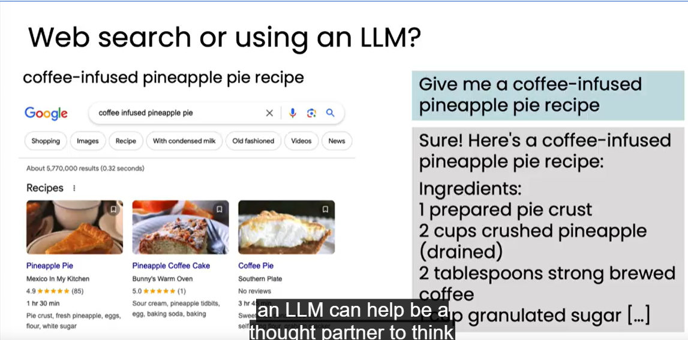

In this case we don’t have proper thing in google search so we can move with the LLMs

What is General purpose technology:

Ai used for many tasks

Focus LLMs do’s

**1)writing:**

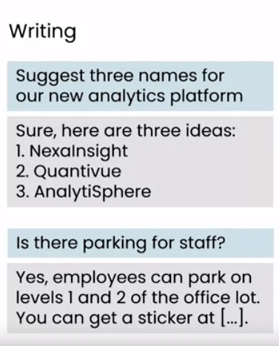

Gen-ai which is used to writing purpose which we can give the prompt it can the answers

If we specific the information about the company they can help to company

**Reading:**

Given a large data it can generate short information

Ex: reading the mails of the Naresh it students and quickly figure outs the complaints or remarks of the students:

And help to route these remarks to appropriate management to handle them quickly.

**Chatbots:**

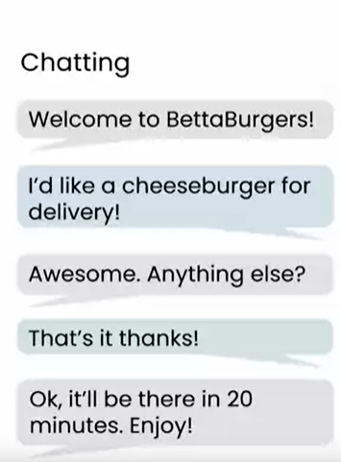

**Writing:**

**Writing a appropriate prompt is very important**

**Write a press release for hiring a new CEO of a company…………….**

**[company_name] welocmes[new_ceo]**

**[city state date] a leading [brief company description]……**

**When we specify the prompt as write a press release for hiring a new ceo of following details**

**Nareshit**

**Hyderabad ts 17 …/**

**It will generate a nice prompt based on you provided details**

**Translation following text into hindi**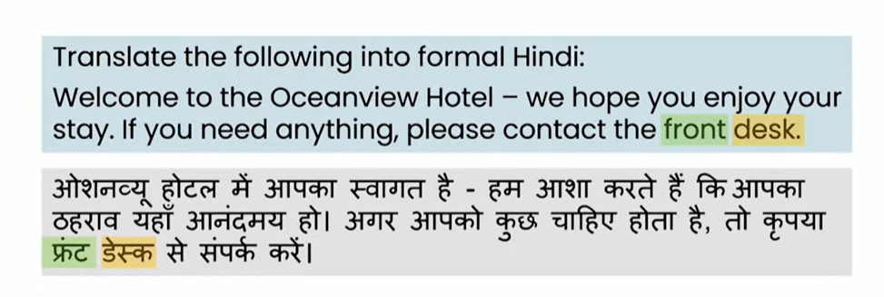

**Reading:**

**Summarizing a long article**

**Summarizing following paper into 300 words.**

**LLMs can summarize calls between agent and customer in call centres to the mangers as it has large amount of data.**

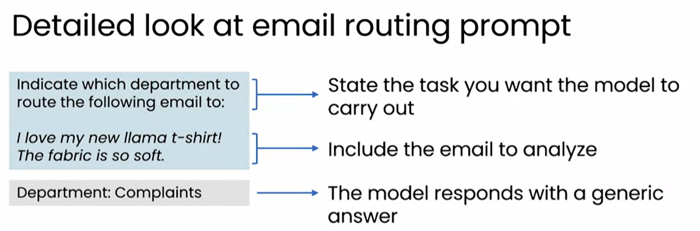

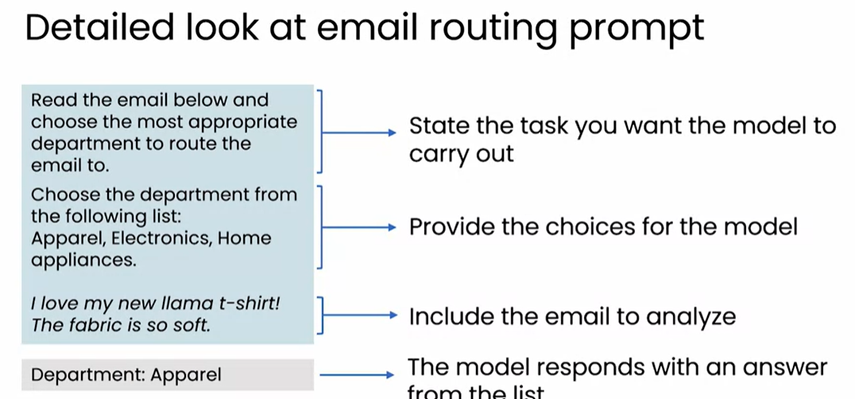

Gen-ai

**writing -task**

**when we produce the relevant prompt it will generate text based on the prompt

If we specify more clearly it will give more clear output to us

**language translation is also possible it can convert the English text in Hindi or other different languages also……

**reading**

**proof-reading [wash in the machine wash-in machine]

**summarizing the article of 300 pages

**summarizing the call centre conversations

**customer email-analysis

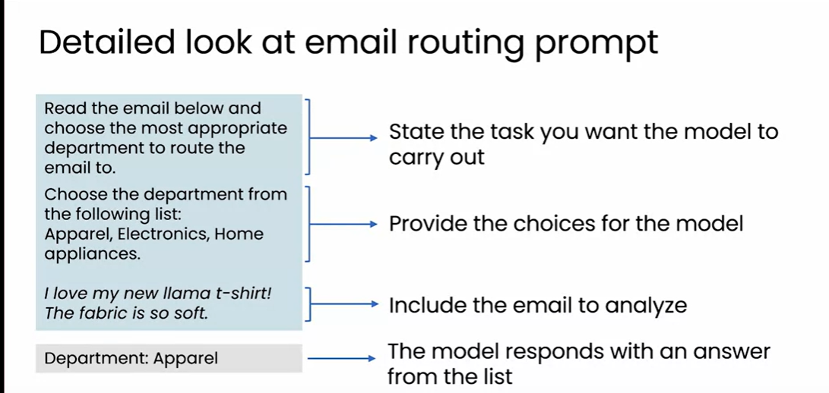

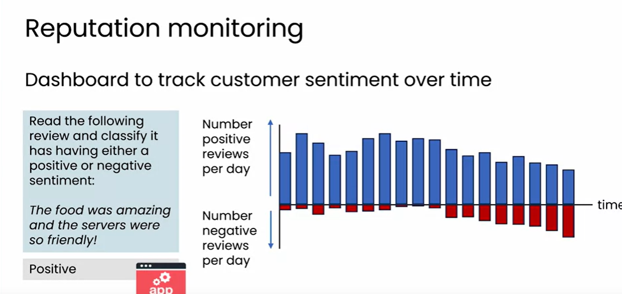

Chatting applications

1)customer service chatbot

2)specialized chatbots

3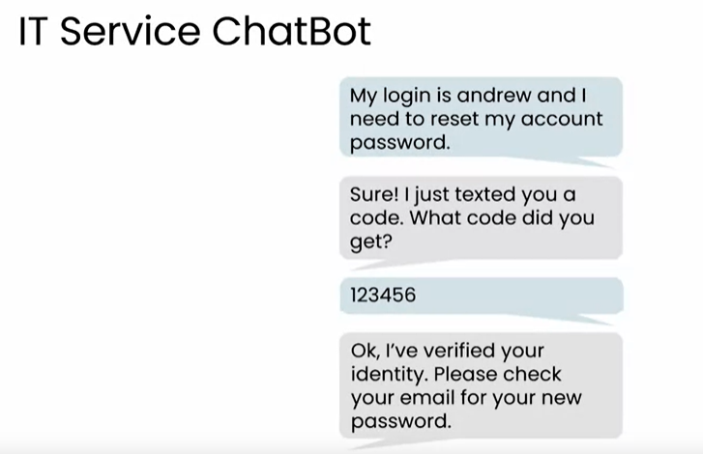

What LLMs can and cannot do???

1)knowledge-cutoffs:

A LLms knowledge of the world is frozen at the time of its training

A model trained on data scrapped from internet in Jan 2022 has no information about more recent events.

Ex: highest gross collection movie in 2023 in tollywold

Result: I don’t have the data on higest gross collection movie

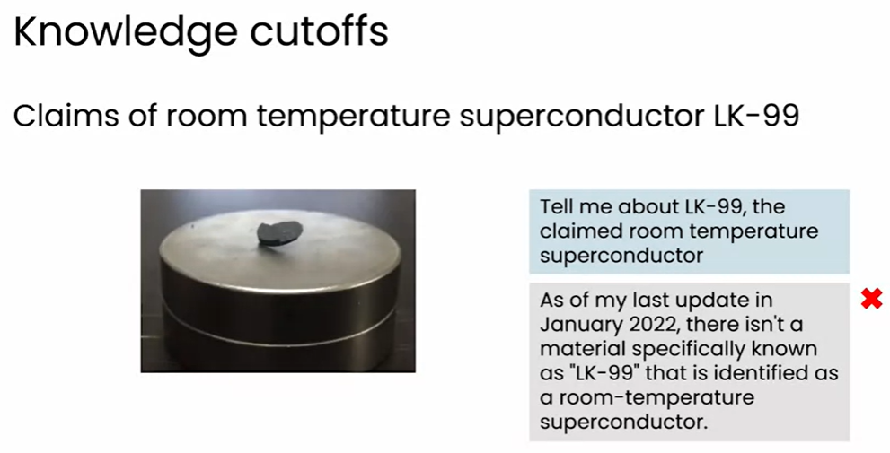

Hallucinations

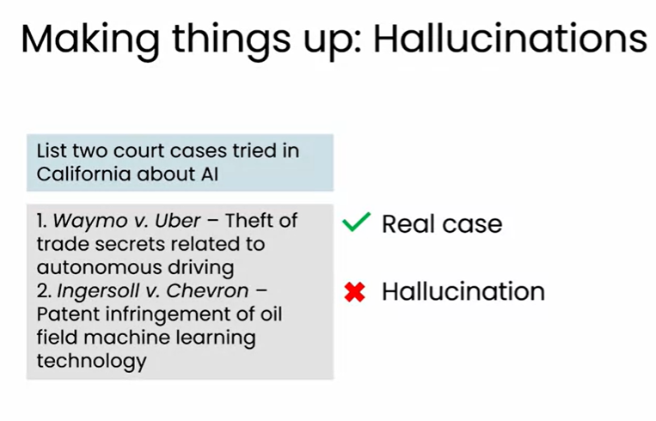

Input and output length is limited..

Many LLMs can accept the prompts upto few thousand lines only

The total amount of context you can give it is limited

Ex: summarize a large textbook it will reject to take it.

Some has longer words some not..

Generative ai will not work on the structured data

So supervised technique is very better compared with genai compared in scenario of structured data

Gen ai will work mostly on best on images audio video which is unstructured data….

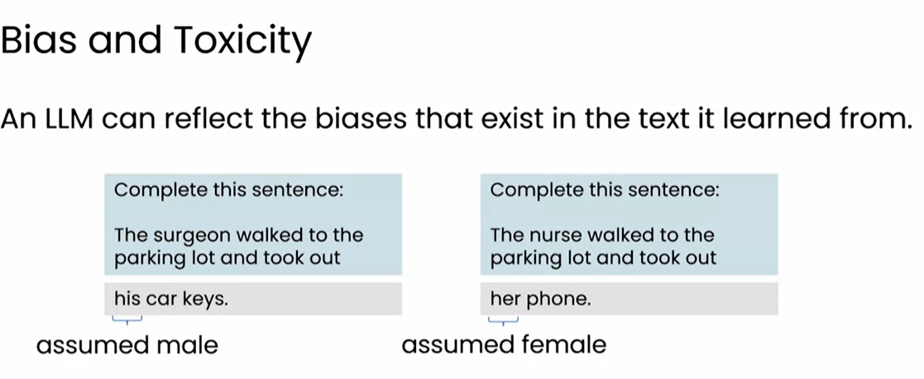

……………. TIPS FOR PROMPTING…………………

Be detailed and specific

* Give sufficient content for llm to compete the task
* In detail content to given

Guide the model to think through its answer

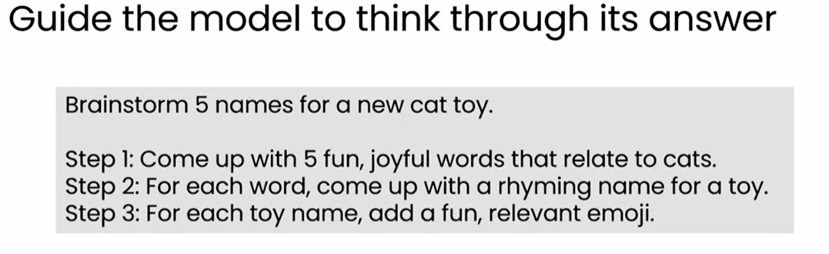

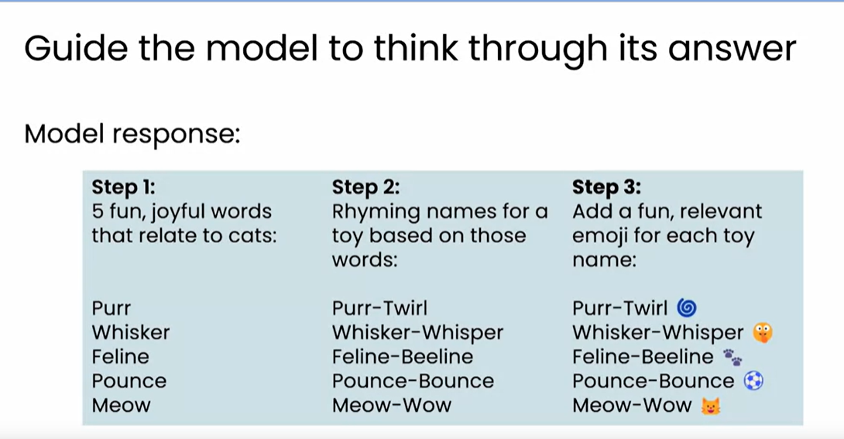

Experiment and iterate

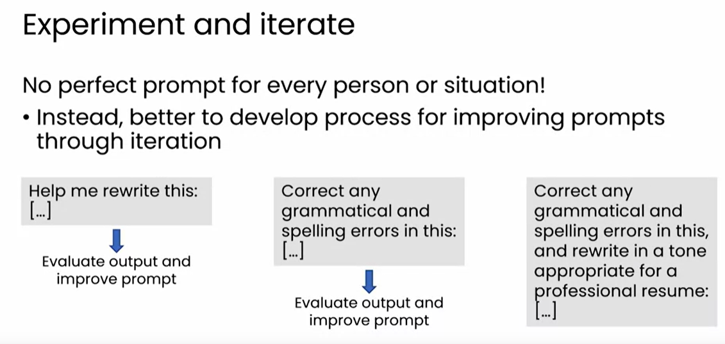

Iterate until you got best results just like doing the experiments…

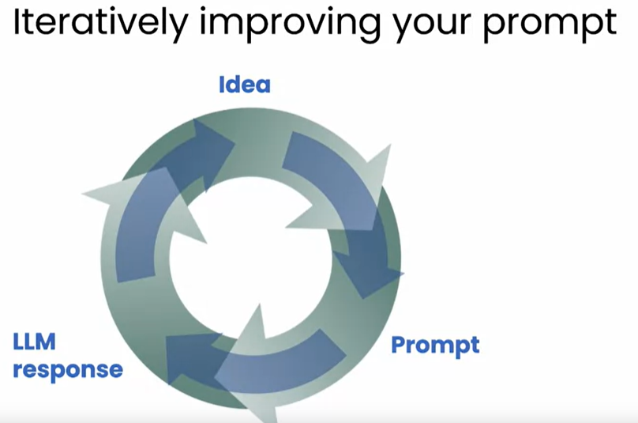

I

Image generation diffusion model

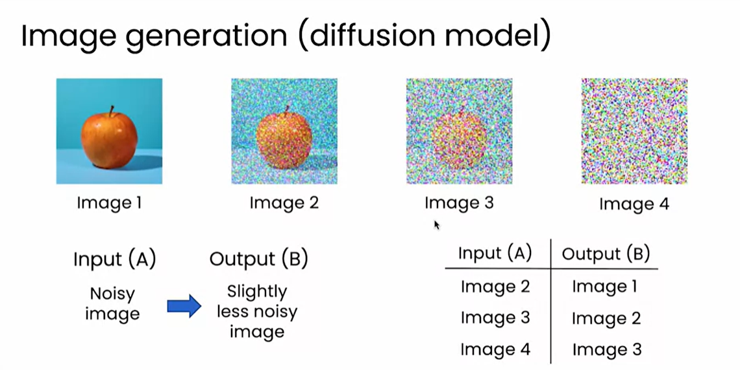

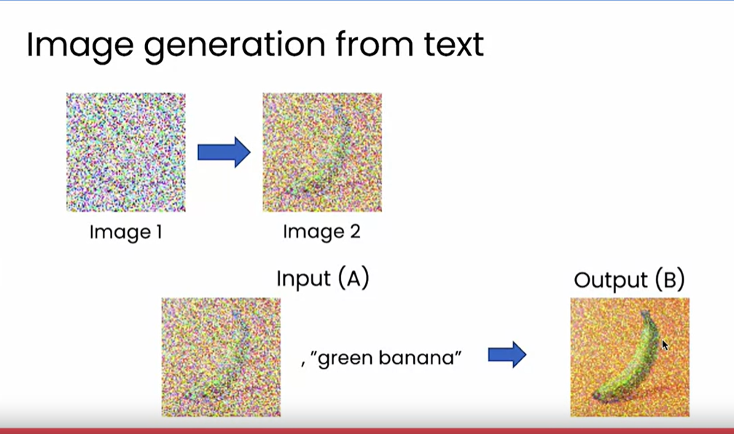

Week-2

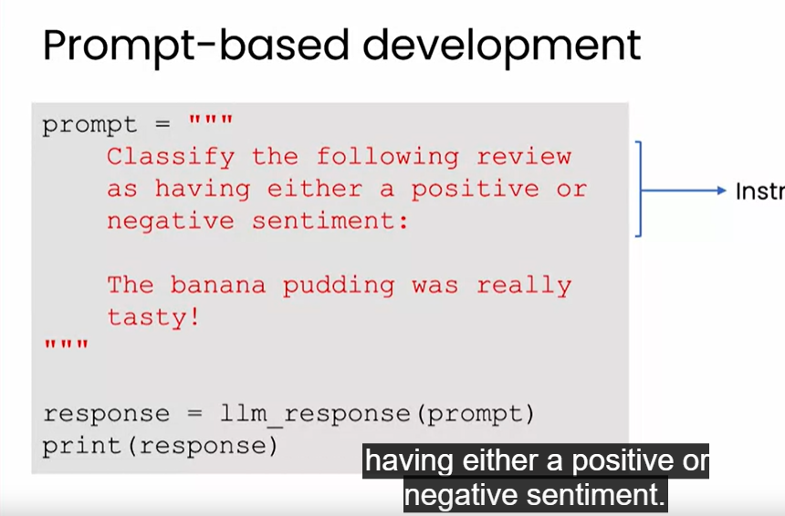

Workflow using gen ai

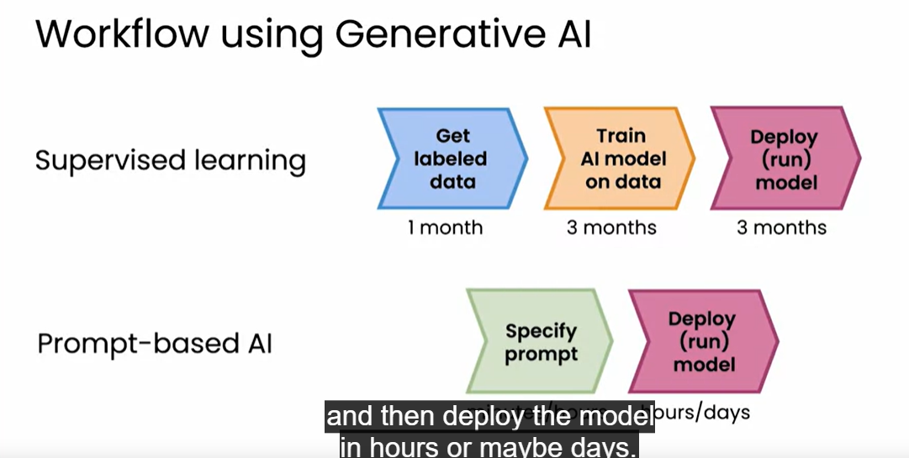

**Life cycle of gen-ai project**

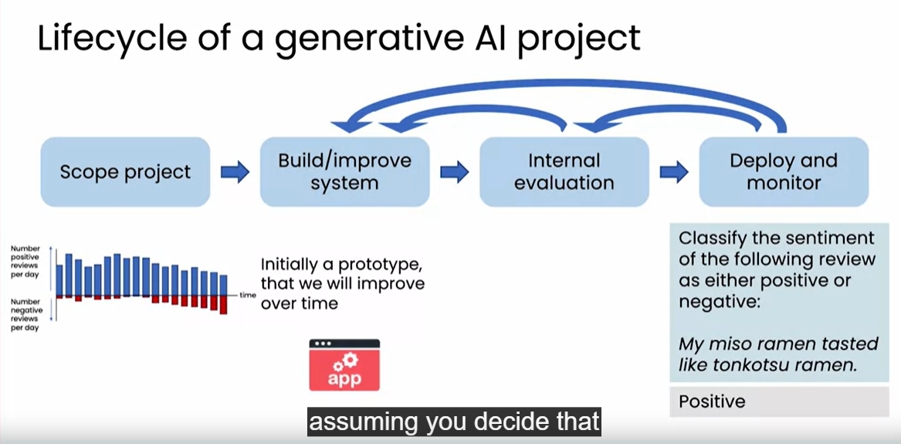

**Tools to improve**

**Building a gen-ai project is a highly experimental process we repeatedly find an fix errors.**

**1 ----try prompt see fix it run again**

**2—retrieval augmented generation (RAG)**

**-Give LLMs to access external data sources**

**3)Fine-tune models**

**Adapt llm to your task**

**4)pretrain models**

**Train LLM from scratch**

**RAG:**

**Step-1 given question search relevant document for your answer**

**Step-2 incorparate retrived text into an updated prompt.**

**Step-3 Generate answer from new prompt with additional context.**

**\*\*\*\*\*\*\*\*\*\*\*\*\*\*\*8**

**RAG is an important technique that is enabling many LLms to have context or to have information beyond what it may have learned from internet..**

**RAG application**

**1)Ask your pdf**

**2)chat pdf**

**3)pdf.ai**

**4)tactic**

**4)light pdf**

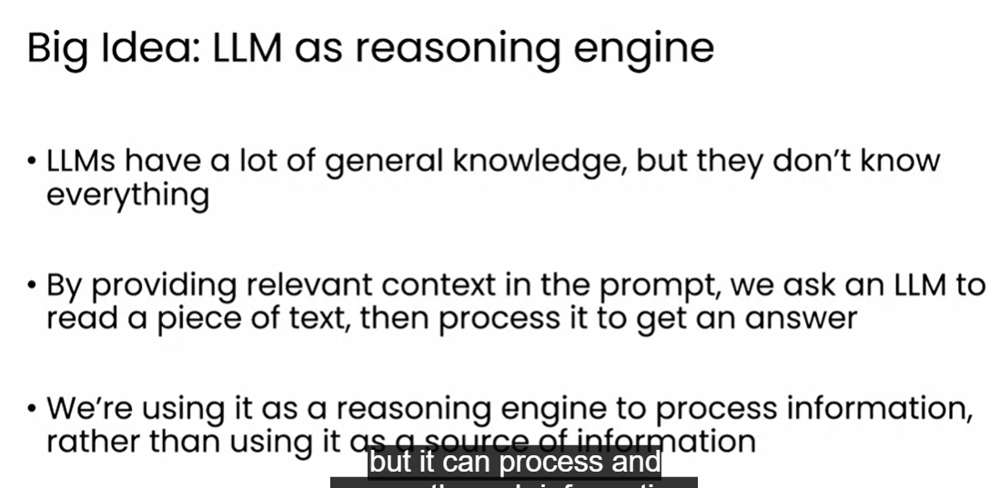

**Fine-tuning**

**Pretraining LLMs**

**Many teams are pretraining general purpose LLMs by learning from internet text**

**May take $10 of millions and many months and huge amount of data**

**Model-size**

**Pattern matching and basic knowledge of world**

**Closed -source**

**Cloud programming -interface**

* **Easy to use in applications**
* **Marge large/powerful models**
* **Inexpensive**
* **Risk in vendor lock in**

**Open -source**

**Full control over model**

**Can run on your own device**

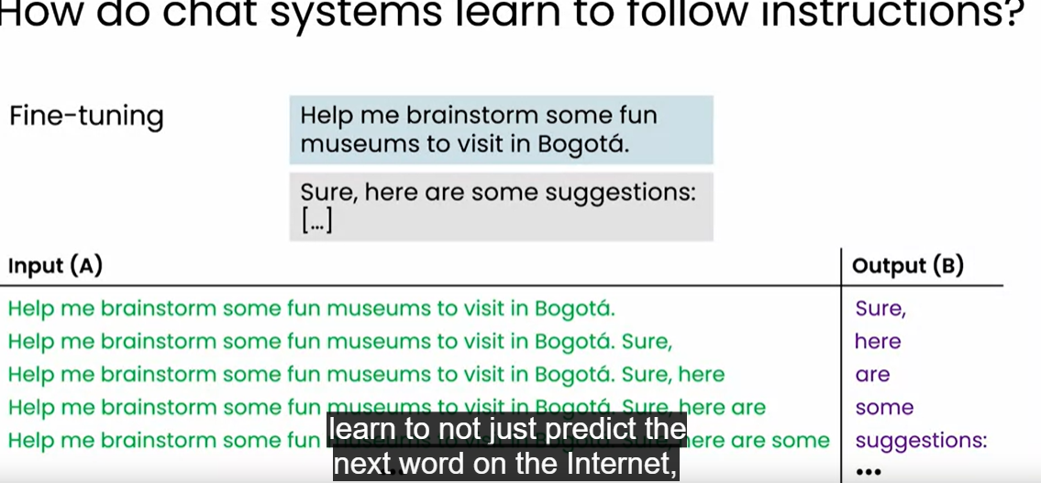

**RLHF(reinforcement learning from human feedback)**

**Improve the quality of answers**

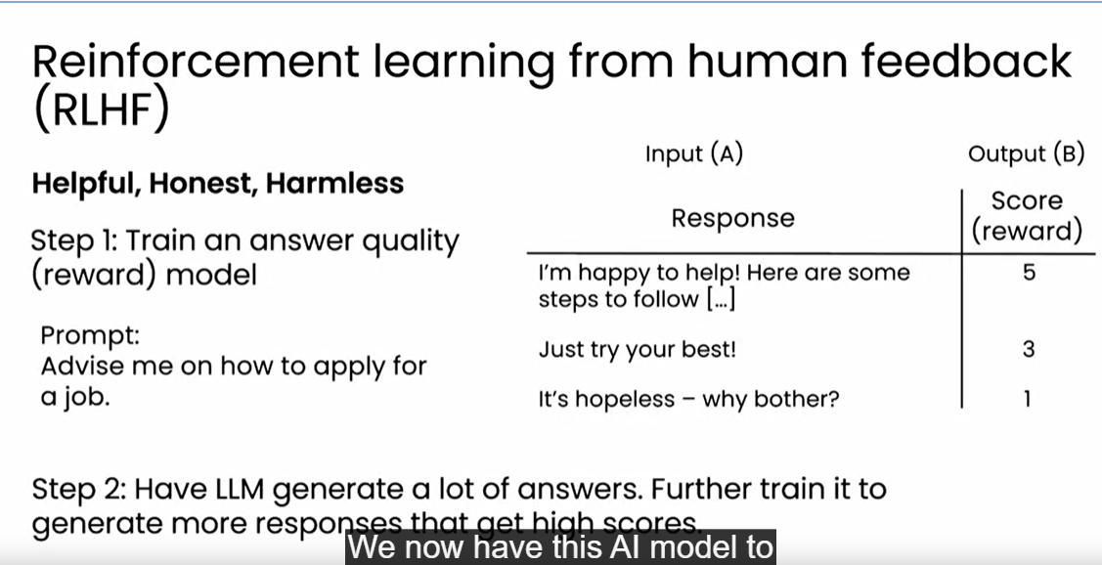

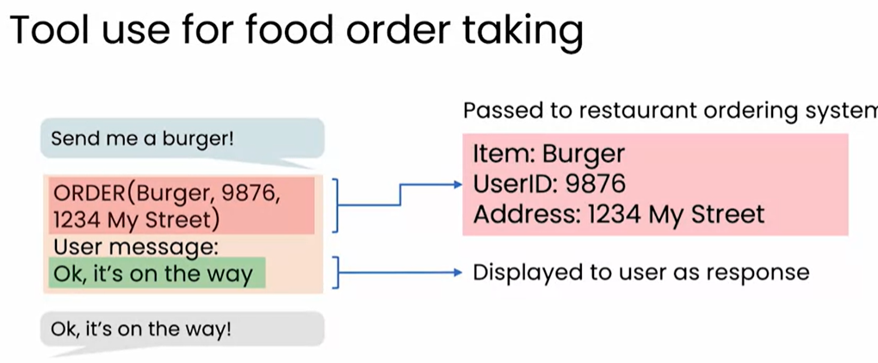

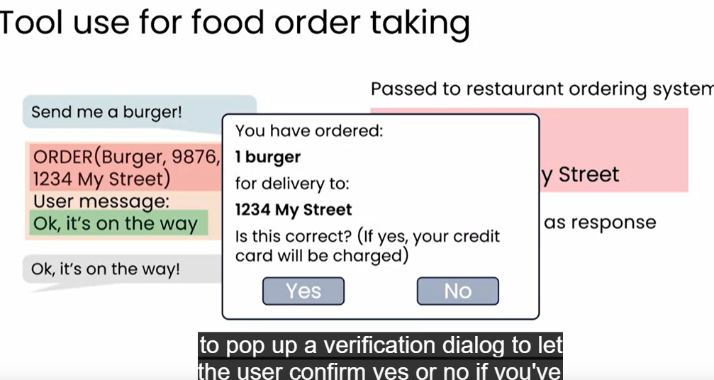

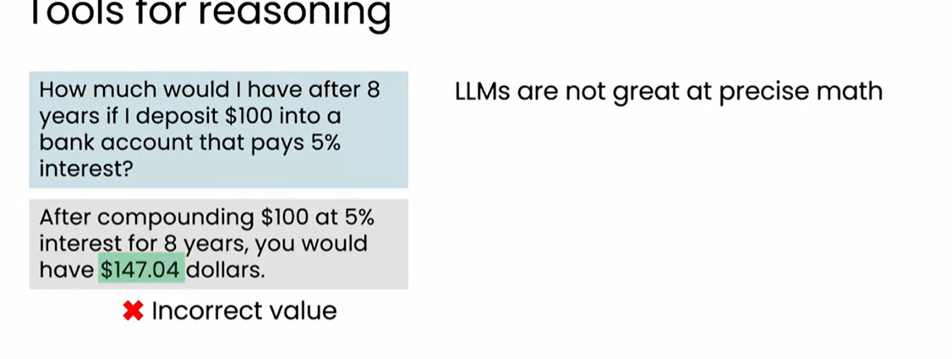

**Giving siginifacnt tools for llms generates correct values**

**Ex:calculator tool**